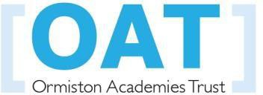

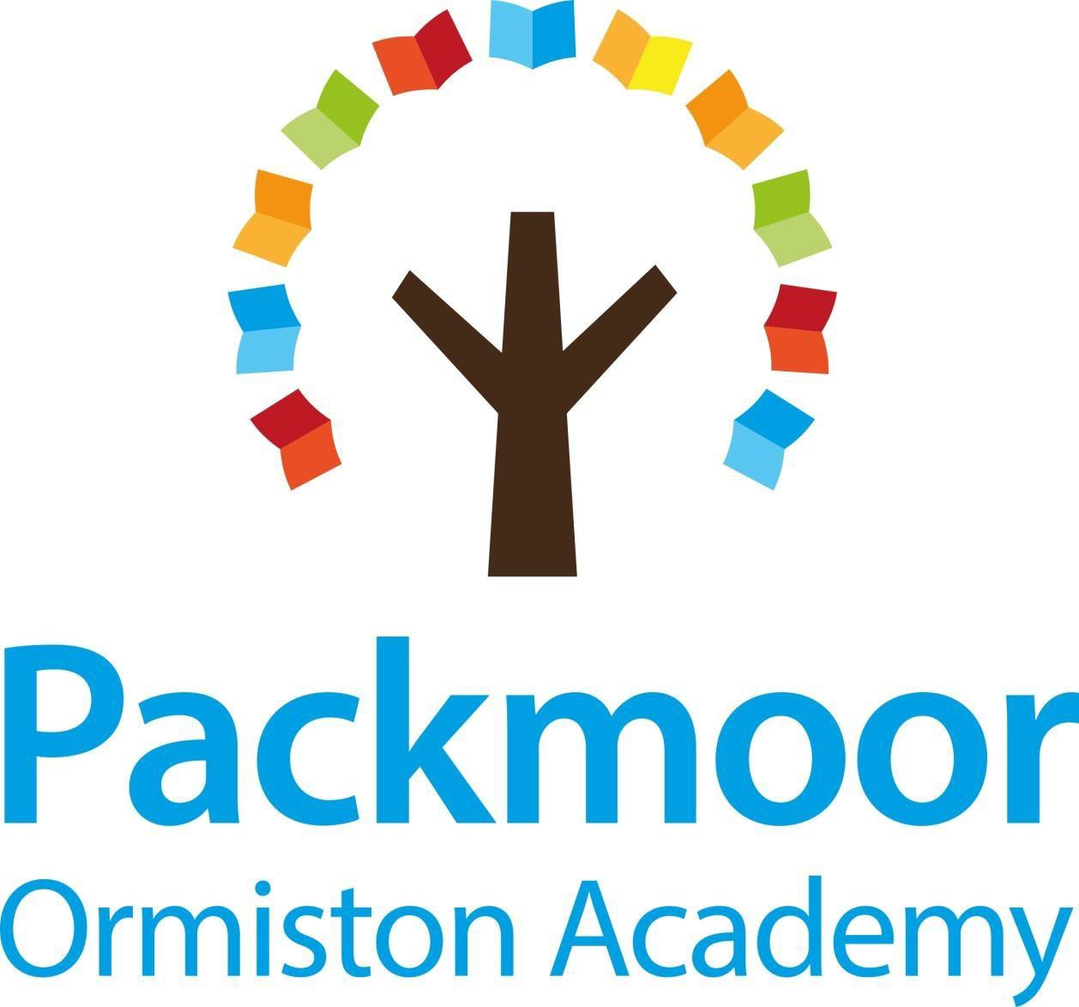

Modern Foreign Language (MFL) Policy

Date adopted: September 2020
Next review date: September 2023

Packmoor Ormiston Academy
Modern Foreign Language(MFL) Policy
Statement
Teaching of a modern foreign language should focus on enabling pupils to make substantial progress in one language. The teaching should provide an appropriate balance of spoken and written language and should lay the foundations for further foreign language teaching at key stage 3.

A high-quality language education should foster pupils’ curiosity and deepen their understanding of the world. The teaching should enable pupils to express their ideas and thoughts in another language and understand and respond to its speakers, both in speech and in writing. It should also provide opportunities for them to communicate for practical purposes, learn new ways of thinking and read literature in the original language. Language teaching should provide the foundation for learning further languages, equipping pupils to study and work in other countries.
(DFE National Curriculum 2013)
Aims and objectives of Primary Language education at Packmoor Ormiston Academy.

- To understand and respond to spoken and written French from a variety of authentic sources.

- To speak with increasing confidence, fluency and spontaneity, finding ways of communicating what to say: including through discussion, asking questions and responding to them.

- To write for different purposes and audiences, using the variety of grammatical structures that have been learnt.

- To develop enthusiasm for language learning.

- To increase European awareness.

- To develop the children’s understanding of themselves and their culture.

- To awaken interest in foreign cultures and lifestyles.

Strategies for teaching at Packmoor Ormiston Academy.
We follow the National Curriculum Framework for MFL laid out in our Programme of Study (2013).
Most lessons are taught by the class teacher using Rigolo, an interactive Scheme. Some lessons covering the cultural side of France and the basics in spoken French are recorded by J Guillon and then used by class teachers throughout Key Stage 2.
Key Stage 2
Years 3 to 6 have an hour of French each week. This takes the form of one 45 minute lesson using Rigolo or a recorded lesson. This is then accompanied by shorter lessons throughout the week, making French cross curricular eg. register time, morning work about numbers and colours, songs, weather charts.
Key Stage 1
Although it is not compulsory for children to learn a language in Key Stage 1, at Packmoor Ormiston Academy, we provide the opportunity for children to develop some awareness of French through learning basic vocabulary. Eg. answering the register in French, learning to say their name, counting and learning songs.
It is important for French to be visible around the school through displays in classrooms and corridors. Cross-curricular links are made where possible and appropriate.

CURRICULUM PLANNING
The Rigolo Scheme of Work for Years 3 to 6 is based around the National Curriculum Framework for MFL Programme of Study (2013) in terms of topics studied. Each unit contains key grammar and vocabulary and aims to reinforce other areas of the curriculum, giving opportunities to reflect on similarities and differences between countries where French is spoken. It assumes no previous knowledge of French, although it is planned for progression as pupils go through the school, ensuring a basic knowledge of a wide variety of topics and offering tasks of increasing complexity as pupils grow. Objectives are placed into books each half term to highlight coverage.
Equal Opportunities and Inclusion.

At Packmoor Ormiston Academy we teach French to all children whatever their ability. French forms part of the school curriculum policy to provide a broad and balanced education to all children. Through French teaching we aim to provide learning opportunities to enable all pupils to make progress. We do this by setting suitable learning challenges and responding to each child’s different needs.

We believe that all children should be equally valued at school. We will strive to develop an environment where all children can flourish and feel safe.

Packmoor Ormiston Academy is committed to inclusion. We aim to enhance a sense of community and belonging, and offer new opportunities to learners who may have experienced previous difficulties. We are committed to giving all our children every opportunity to achieve the highest of standards, regardless of their age, gender, ethnicity, attainment or background.

Assessment
Formative assessment opportunities arise naturally in the course of teaching French. The children’s work is completed in French books where there is a range of activities and written work. J Guillon regularly assess spoken French through interviews and recordings.

Resources.
Rigolo Schemes 1 & 2
Learning Objectives for each half term.
Recorded online resources and PowerPoints provided by J Guillon.

MFL Policy
This policy was updated in January 2022 by J Guillon.

